**Confirm the submission of support tickets**

In this exercise, you'll develop a flow that sends confirmation emails to received support tickets from customers.

To execute the flow of the exercise successfully, use the credentials of a valid webmail account. If the account or server information is false, the flow will fail.

1. Launch the Power Automate for desktop console and create a new flow named **Ticket confirmation**.

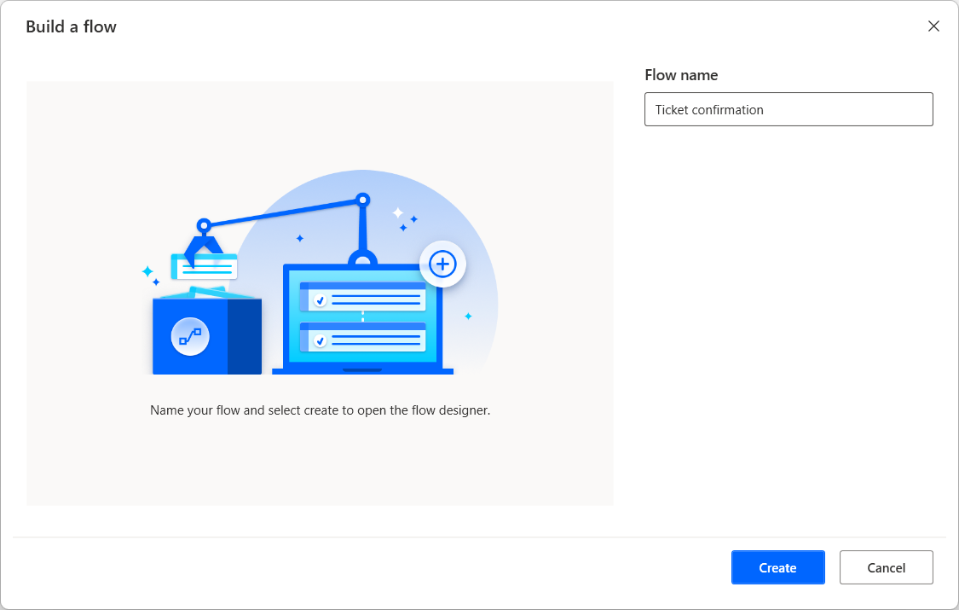

1. Deploy a **Retrieve email messages** action and configure it to retrieve all the unread emails that contain the word **Ticket** in their subject line. Populate the **Mail folder** field with the main inbox folder of your account.

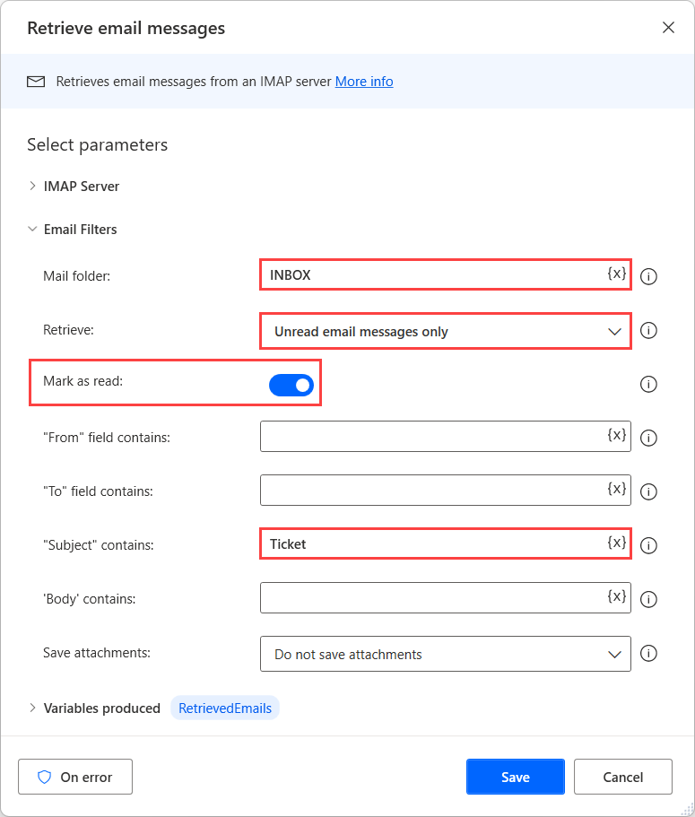

1. To configure the IMAP server, expand the **IMAP server** section of the action and populate the appropriate server information.

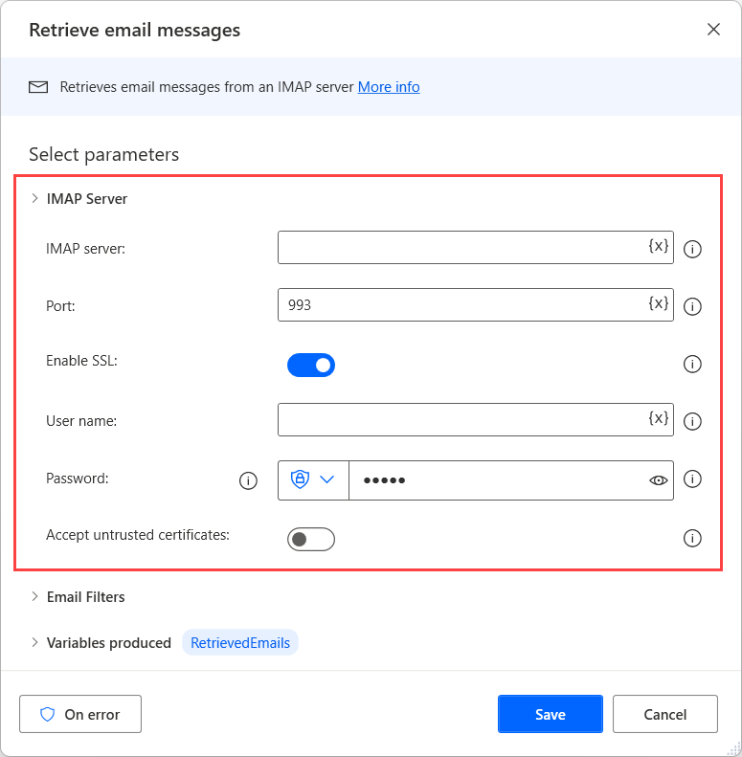

1. Add a **For each** loop to the workspace and set it to iterate through the list that contains the retrieved emails.

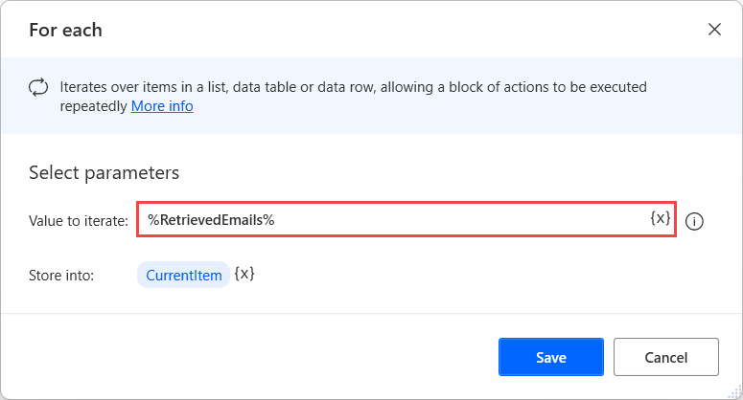

1. Inside the loop, add a **Parse text** action to get the email address part of the **%CurrentItem['From']%** property. To get this specific text part, use the **<(.*?)>** regular expression.

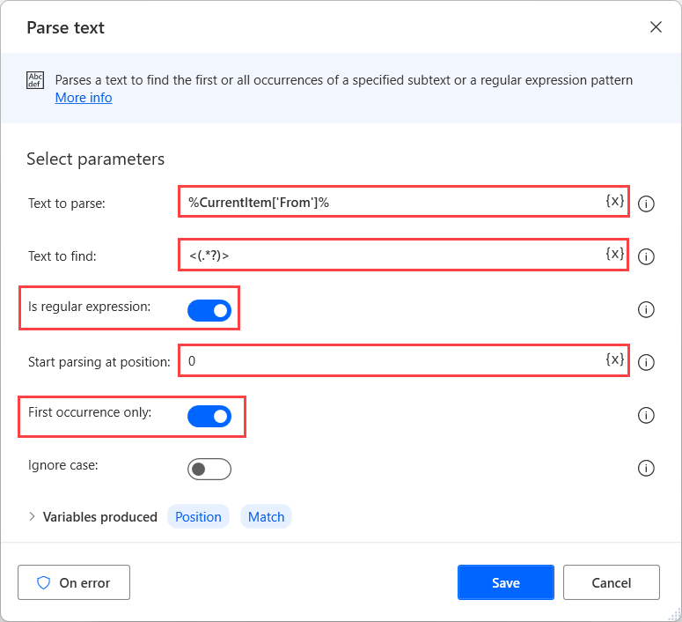

1. Below the **Parse text** action, add a **Send email** action to send an email to each ticket owner. Set the email subject to contain the subject of the received email with a confirmation notation. The body can optionally include a confirmation text.

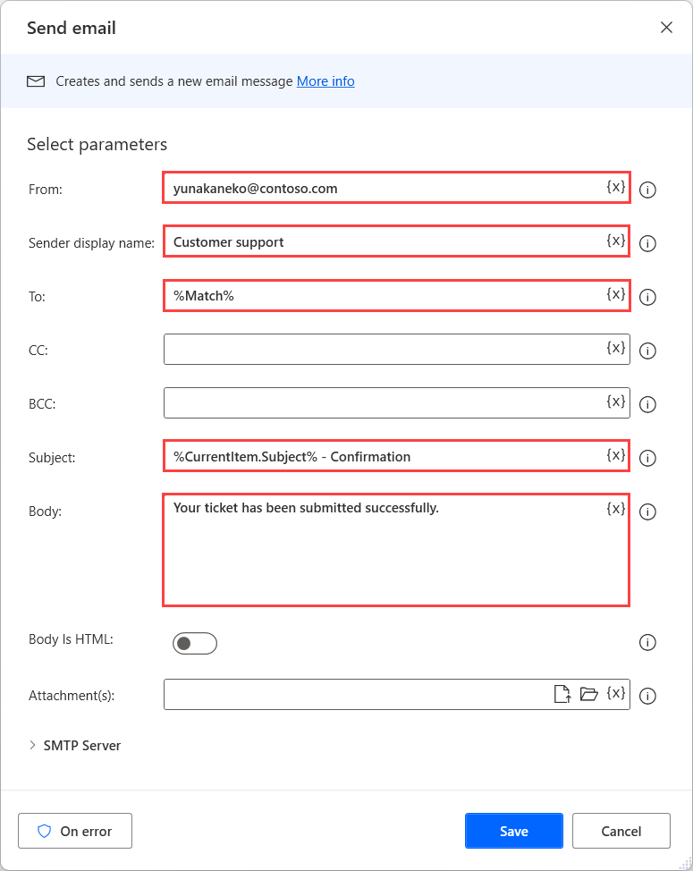

1. Expand the **SMTP server** section of the action and populate the SMTP server's appropriate information.

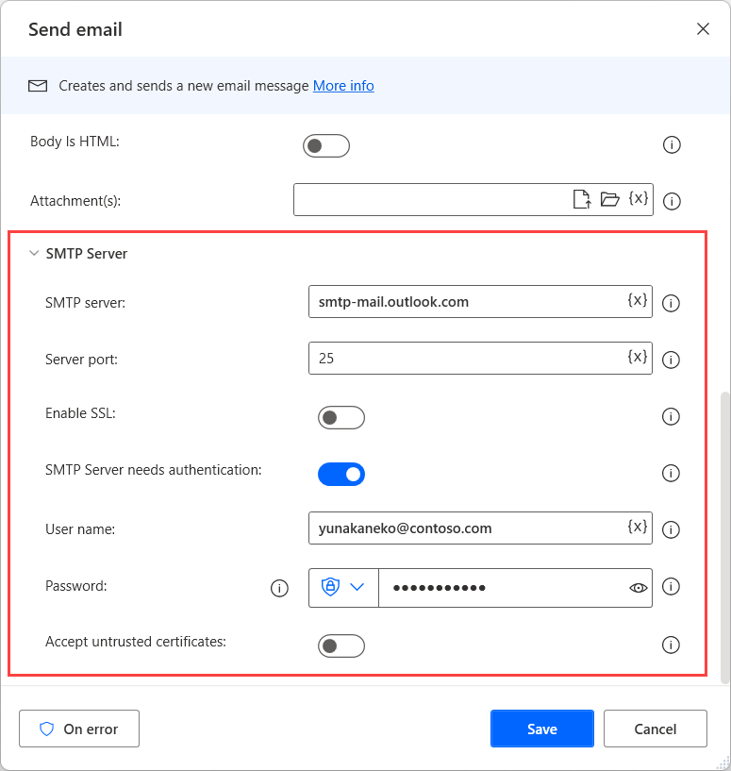

1. Beneath the **Send email** action, add a **Process email messages** action. Set it to move each retrieved email to a folder named **Confirmed tickets**.

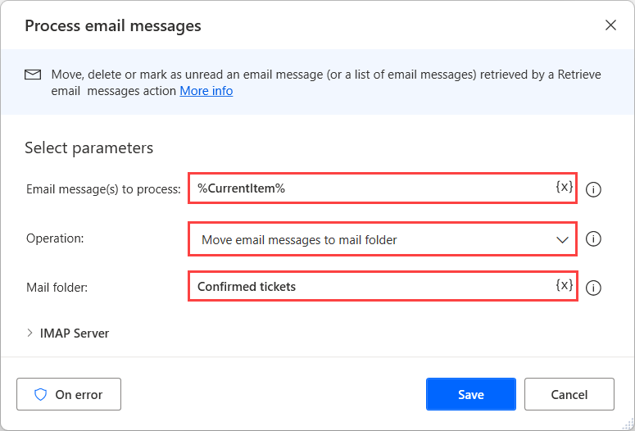

1. Expand the **IMAP server** section of the action and populate the IMAP server's appropriate information.

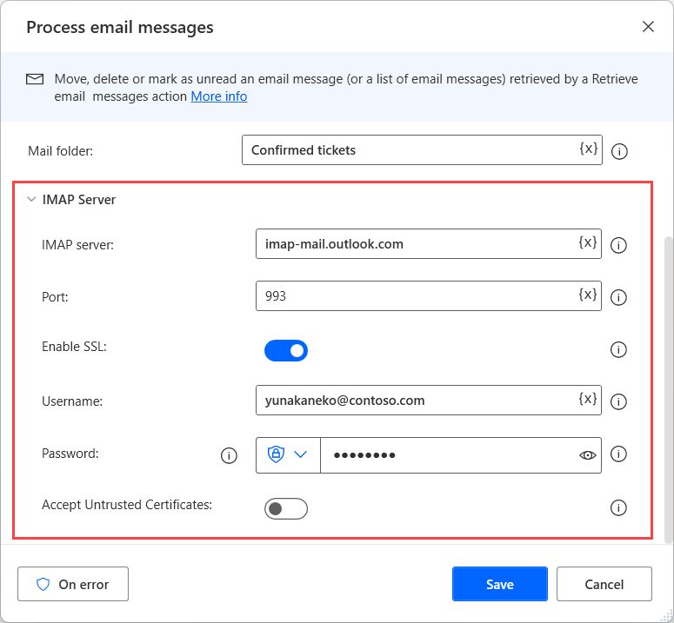

1. Save the flow and run it to test that every action runs as expected.

